Lesson Plan 3
Topic: ICT in our life
Time Breakdown:
- Warm Up - 5 minutes
- Group Activity - 30 minutes
- Closure and Homework - 5 minutes
Objective:  - Explain how ICT affects their everyday lives and the state of our nation  -Give the importance of ICT in our daily lives.  - formulate thoughts how ICT affect in our life | Materials:  worksheets,  A4 letters  Pencils  Markers
Key Terms:
➔ influence
➔ affect
➔ social media
➔ post
➔application
➔account
Warm Up (5 minutes):
Brainstorm:
- How many times have you checked your phone this morning?
- How many status updates have you posted in FB or Twitter today?
- Did you use internet for an hour after you woke up this morning?
- Do you follow a celebrity via his/her social media account?
Group activity (30 minutes):
Teacher’s speech: Modernized, Upgraded, Advanced – these are just some of the words we can use to describe our world in our present generation. Information Communication Technology (ICT), from the word itself,are the applications and technologies we use like cellular phones, computers, wireless signals,televisions and Internet that helps us to disseminate or give information to the public. ICT plays a very big role to me and to the society as well, it helps us in terms of education,business,and our way of living. With the help of ICT, convenience, knowledge and interaction will be easily attained.
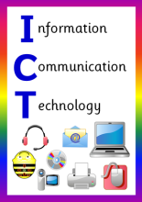
Tired of waiting your postcards from your loved ones abroad? Fed up with finding references on different libraries in different places? With the use of Information Communication Technology, we do not need to prolong the agony of waiting. In just one click, We can already find the answer or the solution to our problem, we can share and download files, videos, pictures and music which we can use either for proposals,reports,presentations needed for school or business purposes or for just mere entertainment. We can easily buy products online or gain money just by posting it on social medias and advertise it creatively. We can have what we want in just a very short period of time without wasting a lot of time,effort and money.
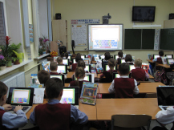

We can gain a lot of information and easily be aware and knowledgeable of what is happening around us. From the latest news and occurrences in any part of the world, to the newest inventions, to the trending updates and innovations. What else would you like to look for? For sure, you will not be left behind. ICT makes our minds full of new ideas, discoveries, and experiences we did not have before and it lets each individual experience a different way of discovering and learning with excitement because of its uniqueness.
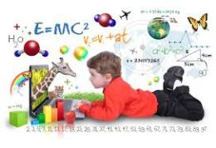
Interaction is also one of the biggest contribution ICT has given. This is the main reason why it was been created. Nowadays, with the help of ICT, we can easily interact and connect with other people living in any part of the world. We can send them messages through emails and social medias or talk to them through calls or can see them through video calls. We can now have interviews, meet ups, long messages just with the use of ICT without giving much effort.
But then, despite of these benefits of ICT, people seems to abuse the usage of it and manipulate it in an inappropriate way. We appear to be so addicted using these technologies where it comes to the point that we are already losing our privacy and we are already hurting others’ feelings and steps beyond their territory and not knowing we are already wasting so much time doing nonsense works with the use of ICT. As users of ICT, we must always observe our responsibility towards it, we must not use it if we do not have a good purpose. Operate it with care and with proper behavior. Limit the usage of these technologies because it may give us danger,if misused,that will lead to certain conflicts and problems. Always remember that technologies are invented to help make our life easier but that does not mean that we can already forget the people around us and the real world.
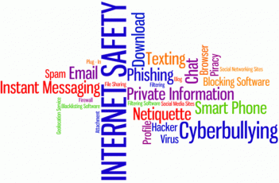
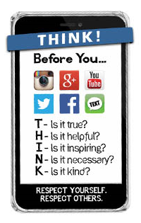
- Activity:
Use worksheet and describe with picture and help my speech: how ICT influence in our life
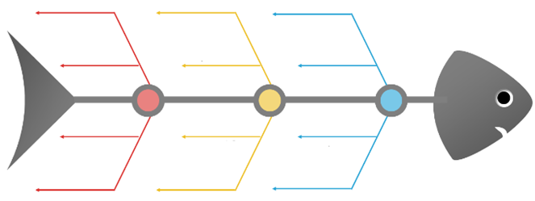
- Make diagram. Use key words.
Closure and Homework (5 minutes):

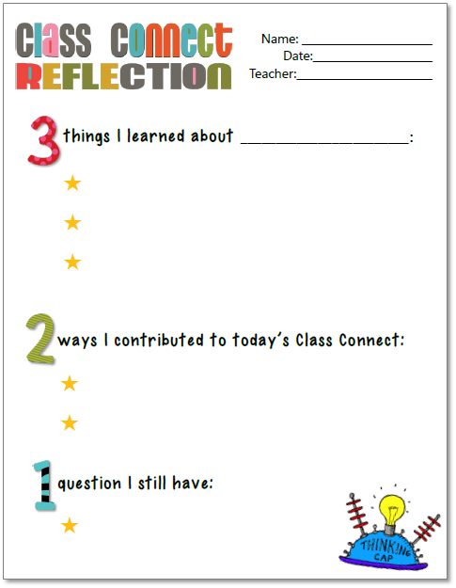
Lesson reflection:
Assessment:

The teacher can assess group participation or award additional points for individual.

