LESSON PLAN №4

|  |  |
| --- | --- |
| 1. Address category | |
| 1.1. Name of the specialty and qualification | 1304000 « Computer systems and software» |
| 1.2. Course, group | 17 VTZ-4,5,6 |
| 1.3. The name of the module / discipline in the section | Computer hardware  PM1. Compliance with labor laws and occupational safety requirements |
| 1.4. The theme of the lesson | Computer components |
| 1.5. Organizational form of the lesson | Group work, independent study |
| 1.6. The knowledge and skills of students necessary to carry out activities on the module/topic | - Identify the parts of a computer.  - Choose computers for different settings.  - Set up a computer |
| 1.7. Opportunities of the training session integration of professional skills and employment skills | - communication skills;  - the ability to perceive information;  - the ability to apply information in practice. |
| 2. Aim of the lesson | |
| 2.1. To promote the development of the following job opportunities and job search, which students will learn in this lesson | - listening skills;  - ability to communicate with partners;  - listen to the opinions of others. |
| 2.2. Training of professional skills, which are learned by students in the process of training | - the ability to organize the workplace correctly;  - ability to work with literature;  - ability to work in a team;  - to think logically. |
| 3. Learning outcome | |
| 3.1. By the end of the lesson, students should know and be able to: | - Identify the parts of a computer.  - Choose computers for different settings.  - Set up a computer |
| 3.2. Quality criteria | Describe the major hardware components of a computer.  Compare and contrast computer features.  Set up a computer.  Identify basic rules for proper operation of a computer.  Apply basic troubleshooting steps for solving common problems. |
| 4. Planning phase | |
| 4.1. Educational-methodical support, reference literature | Гук М. Аппаратные средства ЭВМ ПК, 14-21 бет |
| 4.2. Technical equipment, materials | - interactive whiteboard;  - computer |
| 4.3. Description of the sequence of actions of students | - Describe the major hardware components of a computer.  - Compare and contrast computer features.  - Set up a computer.  - Identify basic rules for proper operation of a computer.  - Apply basic troubleshooting steps for solving common problems. |
| 4.4. The role of the teacher | - an explanation of the terms and the order of their application.  - to provide the students with a basic understanding of the types of computer |
| 5. Implementation of the plan | |
| 5.1. Description of the plan of activities, the content of the activities of the teacher and students (table) | Table "Content and organization of interaction between the teacher and students" |
| 6. Assessment | |
| 6.1. Assessment of the quality of completed tasks | Determination of the degree of assimilation of new concepts and terms. |

Teacher ______________ Mukushova G.K.

signature full name

Content and organization of interaction between the teacher and students

|  |  |  |  |  |  |  |  |  |  |
| --- | --- | --- | --- | --- | --- | --- | --- | --- | --- |
| № | The main stages of the lesson | Types and sequence of actions | Activities of students | | | Joint activities of the teacher and students | Activity of the teacher | | |
|  |  |  | individual | group | intergroup | consultation | instruction | control |
| 1. | Orientation and planning stage | Theme and purpose of the lesson |  | Х |  | Х | Х |  |  |
| 2. | Stage of work performance | Preparation of the workplace |  | Х |  |  | Х |  |  |
| Preparation of materials |  | Х |  |  | Х |  |  |
| Technological process: shorthand dictation, work with a summary,  interactive whiteboard work | Х  Х  Х |  |  |  | Х  Х  Х |  | Х  Х  Х |
| 3. | Stage of evaluation and analysis of final and intermediate results | Evaluation of work on the quality criteria:  Define the term | Х |  |  |  | Х |  |  |

**The theme of course №1.** Understanding the general characteristics and value of the devices of electronic computing. Controlling internal and external devices

**The theme of the lesson №4.** Computer components

**І. Organization moment**

* Who is on duty today?
* What date is it today?
* What day is it today?
* Who is absent today?
* Are you ready for this lesson? That’s great! Let’s start our lesson!

**ІІ. Checking home task (systematization of knowledge)**

**Task 1.** Take the loupe and drag it over the pictures. What picture’s name is incorrect?

|  |  |
| --- | --- |
|  |  |

**Task 2.** Name famous programmers.

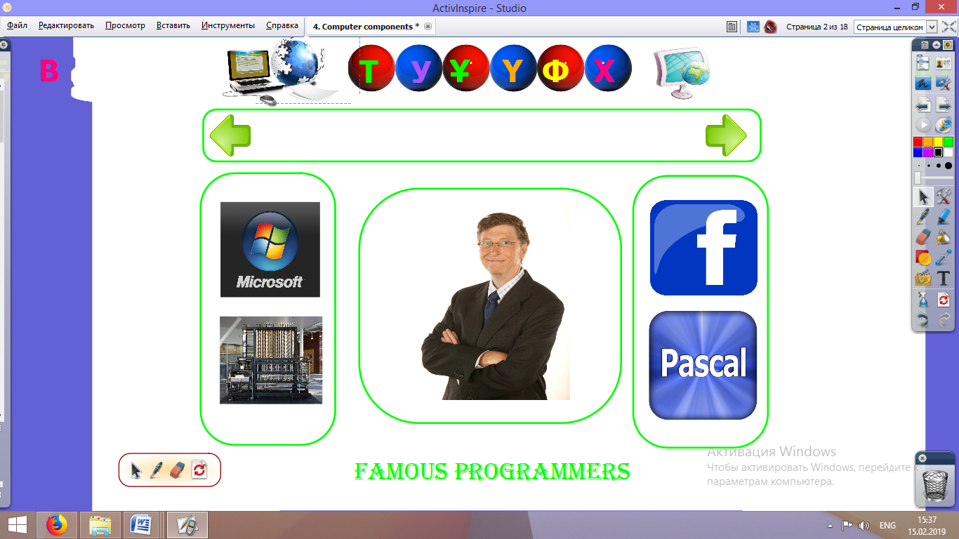

**Task 3.** Make words from letters

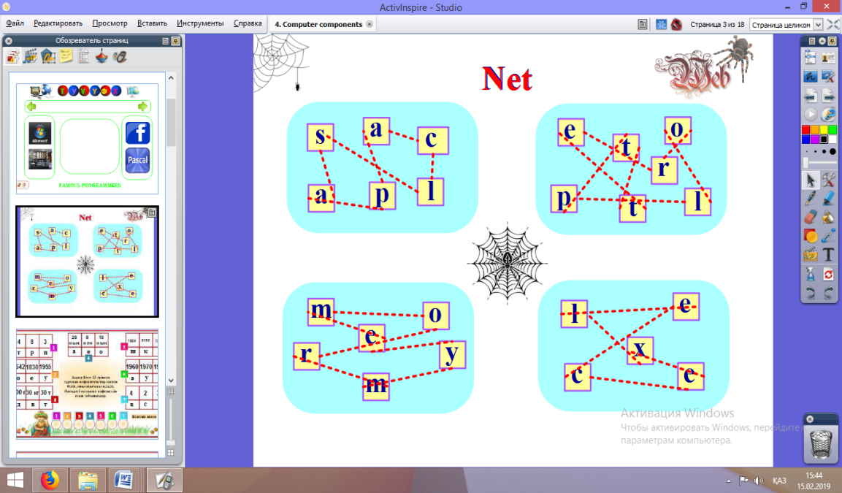

**Task 4.** Answer questions.

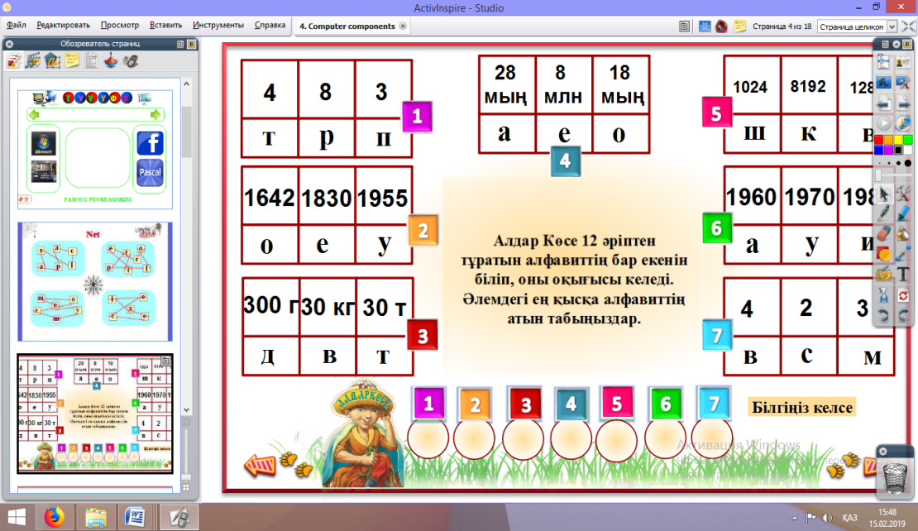

**III. Presentation stage**

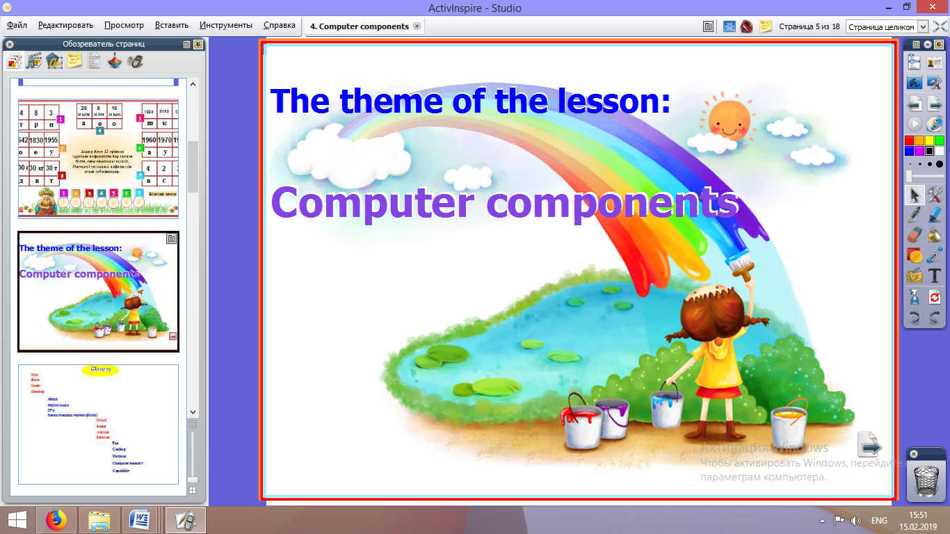

**New words**

|  |  |  |  |  |
| --- | --- | --- | --- | --- |
|  | Case | корпус | корпус | |keɪs| |
|  | To store | сақтау | хранить, сохранять | |stɔː| |
|  | Desktop | үстел үсті | настольный | |ˈdɛsktɒp| |
|  | To attach | байланыстыру | прикреплять, присоединять | |əˈtatʃ| |
|  | Motherboard | аналық тақша | материнская плата | |ˈmʌðəbɔːd| |
|  | CPU | орталық процессор | центральный процессор, цп | |siːpiːˈjuː| |
|  | Random-access memory(RAM) | оперативті есте сақтау құрылғысы | запоминающее устройство с произвольным порядком выборки; оперативное зу |  |
|  | Circuit | схема | схема | |ˈsəːkɪt| |
|  | Board | тақта | доска | |bɔːd| |
|  | Internal | ішкі | внутренний | |ɪnˈtəːn(ə)l| |
|  | External | сыртқы | наружный, внешний | |ɪkˈstəːn(ə)l| |
|  | Fan | желдеткіш | вентилятор | |fæn| |
|  | Cooling | суыту | охлаждение | |ˈkuːlɪŋ| |
|  | Purpose | мақсат | цель | |ˈpəːpəs| |
|  | Computer memory | компьютер жады | память компьютера | |kəmˈpjuːtəˈmɛm(ə)ri| |
|  | Capability | мүмкіндік | способность | |keɪpəˈbɪlɪti| |
|  | Power supply | қоректендіру блогы | блок питания | |ˈpaʊəsəˈplʌɪ| |

**Computer Case** is the piece of hardware that contains most of the components of a computer.

•Where all of the components are stored.

•Two types of casing:

–Tower

–Desktop

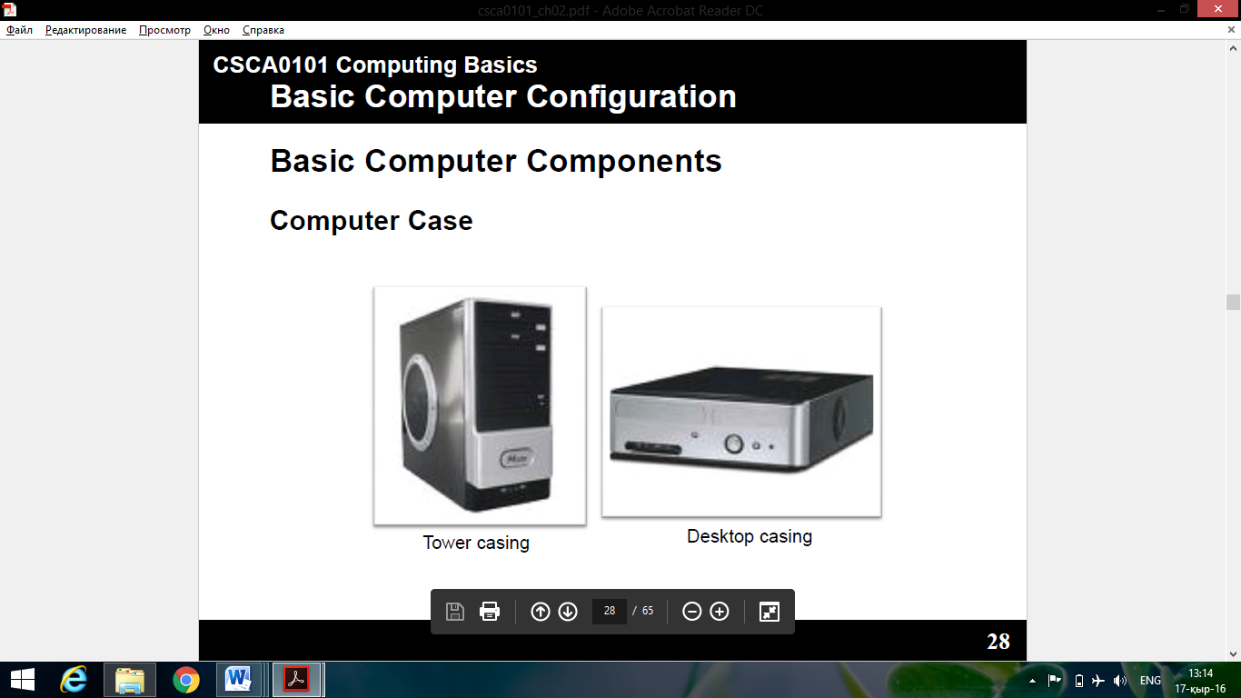

|  |  |
| --- | --- |
| **Motherboard** - the large circuit board in the middle of the case which houses the main components of the computer.  Motherboard:  •The main circuit board of the computer.  •All key internal and external components of the computer plug into the Motherboard. |  |
| **Central Processing Unit (CPU)**  •The CPU, or the Central Processing Unit, is the brain of the computer and the single most important chip in the computer.  •The CPU performs the system's calculating and processing. |  |
| **CPU Fan**  •Any fan inside a computer case used for cooling purposes. |  |
| **Computer Memory**  •Also known as Random Access Memory (RAM)  •Computer memoryis used to store information in electronic devices. |  |
| **Video card**  •A board that plugs into a personal computer to give it display capabilities.  •The display capabilities of a computer, however, depend on both the logical circuitry (provided in the video adapter) and the display monitor. |  |
| **Sound card**  •A circuit board that plugs into your Motherboard that adds audio capability to your computer, providing high quality stereo output to the speakers. |  |
| **Power Supply**  •Used to sends power to all of the other hardware so they can operate.  •Two types of power supply:  –AT (Advanced Technology)  –ATX (Advanced Technology Extended) |  |
| **Hard disk**  •It used to store computer data and program.  •It can hold more data and are faster than floppy disks. |  |
| **Optical Disc Drive**  •An optical storage technology that stores and plays back data.  •Some drives can only read from discs, but recent drives are commonly both readersand recorders. |  |

**Task for fixing the studied material**. Solve the crossword.

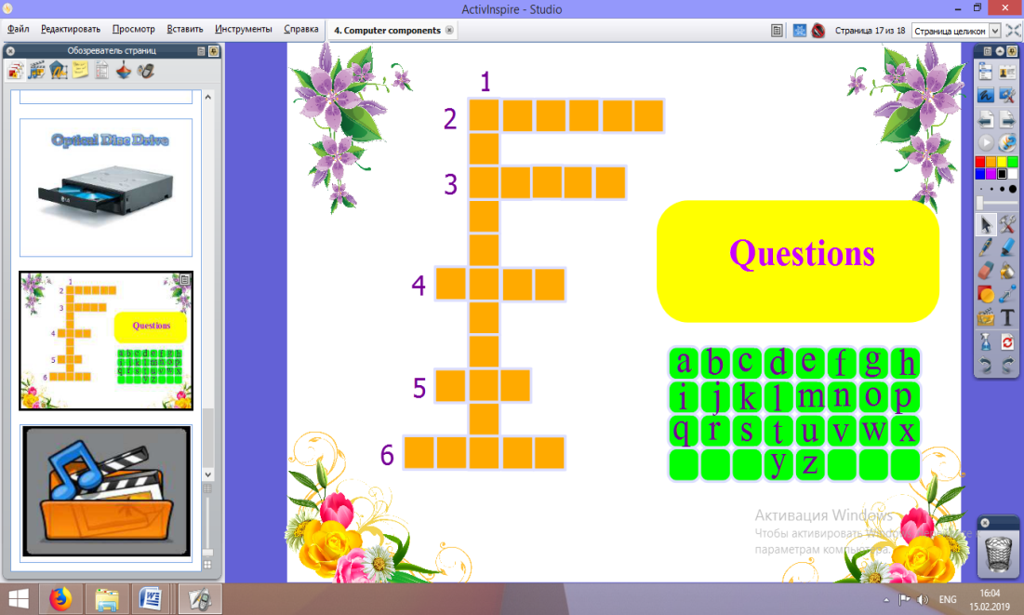

**Listening**

**Listening task**: Watch the video and answer the questions:

1. Witch components are the major components of the computer?

- CPU

- RAM

- the graphics card

- the power supply

- the hard drive

- the optical drive

1. Witch component is also known as CD or DVD drive?

- the optical drive

1. What is the hardware?

- hardware is the physical components

1. What is the software?

- Software is the programs and systems

1. What for is used RAM?

- RAM is used to store files being used by CPU

**V. Conclusion**

Answer the following questions:

1. What is the computer case?
2. What is their function?

* Motherboard
* Central Processing Unit (CPU)
* CPU Fan
* Computer Memory
* Video card
* Sound card
* Power Supply
* Hard disk
* Optical Disc Drive

Teacher G.Mukushova