The theme of course №1. Understanding the general characteristics and value of the devices of electronic computing. Controlling internal and external devices
The theme of the lesson №2. Basic types of computers

CLASSIFICATION OF COMPUTERS: Computers are basically classified into three categories: Analog, Digital and Hybrid, but the digital computers can be categorized depending upon the purpose they do and based on their size and performance.
Types of computers according to the data they process
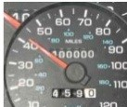
Analog Computers are used to process analog data. Analog data is of continues nature and which is not discrete or separate. Such type of data includes temperature, pressure, speed, weight, voltage, current etc.
Analog computers measure things.
Application areas: Speedometer of a car, Gasoline pump, etc

Digital Computers work with digits to represent numerals, letters or other special symbols.
Digital computers count things.
Application areas: home, educational institutions, office, scientific fields, business etc.

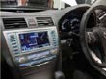
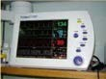
Hybrid Computers: are analog computers controlled by digital computers instead of human beings. A hybrid is a combination of digital and analog computers.
Application areas: Hospitals, Meteorology Department etc

Types of Digital computers according to the purpose they are used for
Special purpose computers: They are designed to do single specific task. For Example – computer for military application or purpose, computers at billing counter in malls etc.
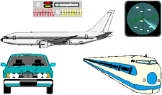
General purpose computers: They are designed to solve wide variety of problems having different set of inputs. For example – computers for banking, sales analysis etc.

Types of Digital computers according to the size and performance
Embedded computers: are designed to be used within the circuitry of appliances such as television, washing machine, refrigerator, bike etc
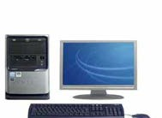
Microcomputers: are designed to be used by single user for performing basic operations like educational activities, playing games. These are mainly used in homes, offices, shops, school etc.

Microcomputers have the following three basic categories
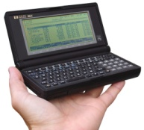
1) Programmable Computers or Personal Digital Assistant or PDA: are designed to carry out day to day task related to sharing or exchange of information by connecting to desktop computers regardless of location. They are used as notepads and address book.

2) Laptop or Desktop or Notebook or Personal Computers: are designed to carry out our day to day personal task. They are used in business and at home.
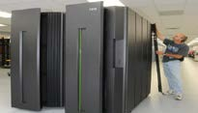
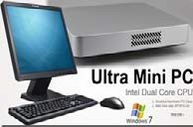
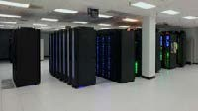
3) Workstations: are similar to personal computers but have greater memory and processing capabilities. They are generally used in industrial, business and in scientific environment that require high levels of computational abilities.

Mini computers: are more powerful computers than microcomputers in terms of processing power and capabilities. They are generally multi-user systems.

Mainframe computers: are designed to handle large volumes of data and information. They are multi-user and multi-processors systems.

Super computers : are designed to be used for doing extremely complicated computations , that also in minimum possible time. They are the fastest, the largest and most expensive digital computers available today. They are best used in Weather forecasting, Nuclear Science, Aerodynamic modeling etc.

Tasks
I. Answer the following questions:
- What is the basic difference between a digital computer and an analog computer?
- An ICU (Intensive Care Unit) of a hospital has _______________ computer to monitor the heart beat of a patient.
- Name the category of the computer that we generally use at home or in Educational institution.
- A hybrid computer is the one having combined properties of ________

How are computers classified into different types?

What are general purpose computer and special purpose computers?

What are the broad classifications of computer on the basis of work (function/activity)?

II. Answer multiple-choice questions:
- A hybrid computer is the one having combined properties of ________
(A) Micro & Mini computers
(B) Mini & Super Computers
(C) Mainframe & Super Computers
(D) Analog & Digital computers
- Which of the following uses a handheld Operating Systems?
(A) Super Computer
(B) Laptop
(C) Mainframe
(D) PDA
- The fastest and most expensive computers are______
(A) Super Computers
(B) Quantum Computers
(C) Mainframe Computers
(D) Micro Computers
- The user generally applies _________ to access mainframe or super computer?
(A) node
(B) terminal
(C) desktop
(D) None of the Above
- Desktop and Personal computers are also known as_______
(A) Super Computer
(B) Quantum Computer
(C) Mainframe Computer
(D) Micro Computer

III. Differentiate between analog and digital computers. Fill the gaps.
Analog computer | Digital computer
1.They process ___________ data. | 1. They process discontinuous data
2.They are special purpose computers | 2. They are ______________ purpose computers.
3.They are expensive than digital  computers. | 3. They are ______________ than analog computers.
4. They produce _________ signals. Eg.  Seismograph etc. | 4. They produce digital signals. Eg.  Personal computer, Laptops etc.

IV. Match the words with pictures:

Hybrid Computer

Embedded computers |  | 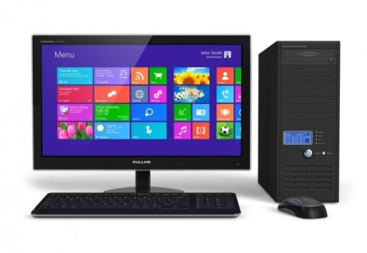
Analog Computers

Digital Computers |  | 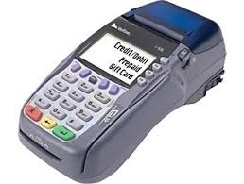
Special purpose computers |  | 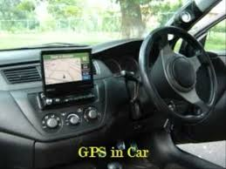

V. Match the words with their definitions:

Mini computers |  | are designed to carry out our day to day personal task. They are used in business and at home
Laptop or Desktop or Notebook or Personal Computers |  | are similar to personal computers but have greater memory and processing capabilities
Workstations |  | are more powerful computers than microcomputers in terms of processing power and capabilities
Super computers |  | are designed to handle large volumes of data and information
Mainframe computers |  | are designed to be used for doing extremely complicated computations , that also in minimum possible time

